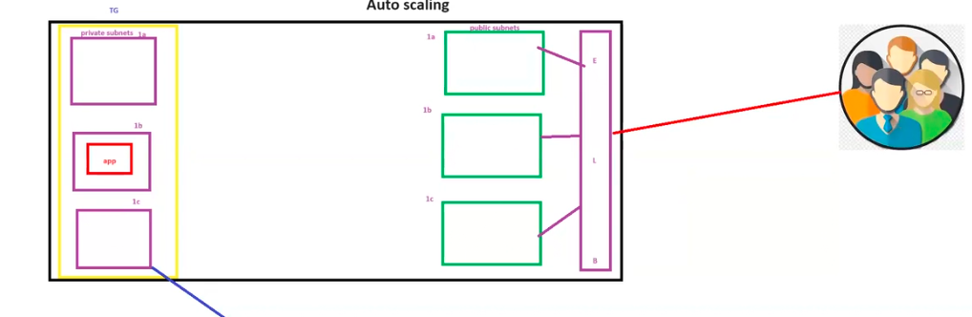

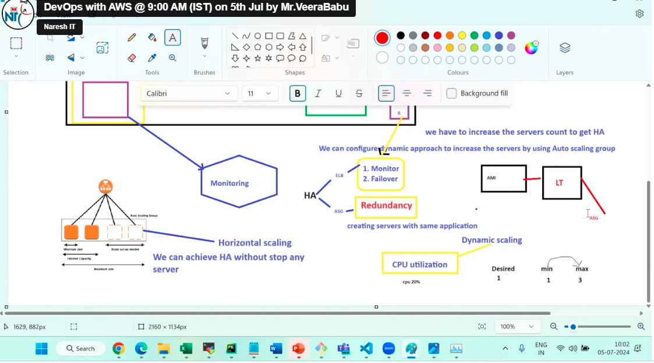

If you monitor the server, we can know load of the server.

We should go for dynamic approach for automatic increase of servers

Not static approach

Dynamic approach we can get by auto-scaling.

ELB takes care of 1. Monitor

2. Failover

ASG takes care of 3. Redundancy (same kind of application or duplicate)

HA, (High Availability) depends on ELB and ASG

ASG follows Horizontal Auto Scaling.

Dynamic approach will depends upon CPU utilization.